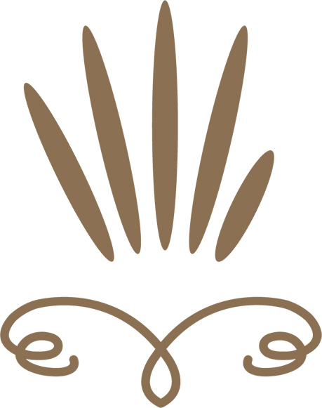

Fertility Massage Training

Course Prospectus
Presented by Clare Spink N.D - Founder

Course Overview

4 Day Practitioner Course
Offering a 4 day Spiritual, Practical & Theory course for any woman who hears the call to offer women’s womb massage to women through all stages of their life, including Menarche, Menstruation, Fertility and Menopause…
“A Fertile Womb is a Creative Womb – one that creates life, visions, abundance and fulfilment”

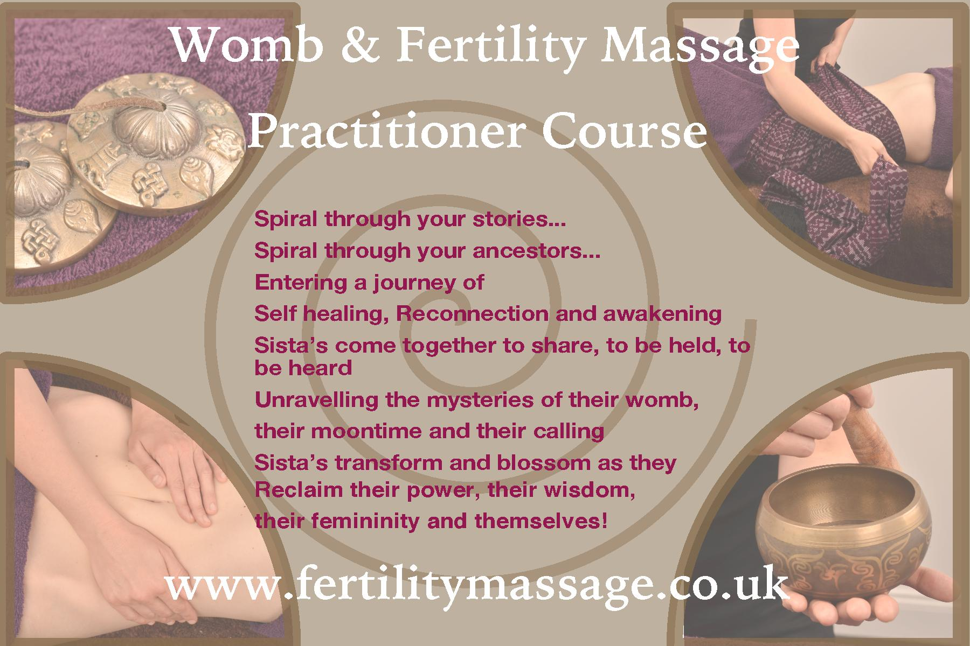

Course Overview
This practical hands-on course will teach you how to safely perform the womb, digestive & sacral massage on yourself and your clients. It is important that practitioners choosing to offer Fertility Massage gain a good understanding of the fertility process, common conditions presented by clients and knowledge to help clients whilst remaining within the scope of their professional training.

Fertility Massage is an incredibly powerful and emotionally releasing therapy and should come from the practitioners womb and heart; therefore, the course commences with a womb blessing and meditation to help practitioners cleanse and connect to their own wombs.

If you have an interest in Women's Health, then this course is for you. With a strong focus on the physical and energetic approach to the womb, this therapy is suitable for women of all reproductive stages, regardless of whether they are trying to conceive.

Sisterhoods are created…

“FROM MY HEART…

TO YOUR HEART…

I WELCOME YOU SISTER””

Course Content
- History & effects of fertility massage
- Client Care
  - Advising clients on what to expect during & after a treatment.
  - After-care advice including Yoni Steams
- Consultation & Case Taking
  - For personal records and as part of the undergoing research on Fertility Massage.
- Practical Modules
  - Receive & demonstrate the fertility massage movements
  - Understand their physiological and psychological effects.
  - Evaluate and review the massage treatment/programme
- Theory Modules (Video Downloads and Powerpoint Handouts - Home Study)
  - Anatomy & Physiology - Participants will be provided with a course manual prior to attending the course. The A & P section is a recap of the information covered in the manual.
  - This topic provides participants with a good understanding of the placement of abdominal organs & the changes of the womb during the menstrual cycle and impact on health.
  - Fertility Theory - Understanding theory that is relevant to Infertility/Fertility to give participants a better understanding to enable them to help their clients, and also know when they need to refer clients on and only work within the realm of their qualifications.
  - Fertility Pathologies - This topic covers common fertility pathologies to provide participants with an understanding of conditions clients may present with and how Fertility Massage may assist their clients.
  - ART & Fertility Massage - An overview of the different Assisted Reproductive Techniques (ART) and how Fertility Massage can be used alongside ART.
  - Menstrual Cycles - Understanding the role of the hormones and mucus during the menstrual cycle will help participants to guide and empower clients.
- Meditation - Starting the course with a meditation helps to bring participants in to the correct space to enable them to connect to their bodies, in particular their womb. This particular style of massage requires therapists to be working energetically and start by understanding the healing process & connection within their own womb.

Learning Outcomes
Upon completion of the 4 day course, each participant will know or be able to:
- Explain and demonstrate the fertility massage movements and their physiological and psychological effects
- Demonstrate the massage to the reproductive organs to aid circulation and improve ligament restrictions
- Demonstrate the massage to the digestive organs to aid circulation, enhance peristaltic action and improve elimination
- How to powerfully integrate deep tissue, visceral and acupressure techniques to facilitate successful and productive bodywork and aid emotional release
- Demonstrate the massage to the sacrum and coccyx to aid circulation, improving nerve flow and release tension
- Demonstrate traditional Rebozo techniques to relax, support and release tension
- Identify the placement of the structures to be worked over and explain their function, particularly their role in fertility.
- Understand and explain the importance of referral procedures and working within scope of practice
- Evaluate and review the massage treatment/programme
- Understand and define the menstrual cycle, it’s hormones and pathologies and fertility issues.
- Define the difference types of cervical mucus and how this will help clients to understand their menstrual cycle
- Describe the different methods of Artificial Reproductive Technology (ART), their different protocols and how to implement the massage safely alongside these.
- Define the macro nutrients and explain their role in preparation for fertility
- Describe the role that a healthy lifestyle has on preparation for fertility and how to implement with clients whilst remaining within scope of practice, or referring on to other practitioners.

Please note that this therapy is to aid fertility.
There are no guarantees that clients will fall

pregnant after receiving this massage.

Course Outline

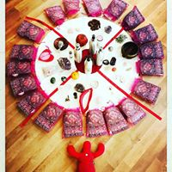
Module 1
Womb Blessing & Meditation
Basic Anatomy & Physiology
Womb Massage Demonstration
Womb Massage Practical

Module 2
Abdominal & Womb Massage Demonstration
Abdominal & Womb Massage Practical
Menstrual Seasons (Explore the 4 seasons with an embodied experience)

Module 3
Sacral Massage Demonstration
This course was so much more than learning the physical, practical and spiritual techniques to aid and treat fertility and digestive conditions. It was a sacred space where each member healed, grew and evolved through their own journey and will continue to do so for some time!
Fidelma, Belfast 2014
Sacral Massage Practical
Rebozo & Wrapping Ceremony
Reclaiming Spiral

Module 4
Self Care Discussion and Q&A
Complete Fertility Massage Practical - Assessment
Closing Ceremony

**Theory is covered as distance learning, using downloads and handouts

to accompany them. There will be allocated time to discuss theory

after participants have viewed them**

Assessment
You can attend the course either for your interest or if you wish to receive Fertility Massage Therapy Certification, you will need to fulfill the following requirements:

Practical Examination
The practical exam is held on the final day. I do not expect you to “know” the massage, however, it is an opportunity to demonstrate your movement, energy and skills in a relaxed environment.

Theory Examination

The theory exam is an open-book exam, made up of multiple choice or short answer which you complete at home with the aid of the video downloads and accompanying handouts.

Home Study

Case Studies
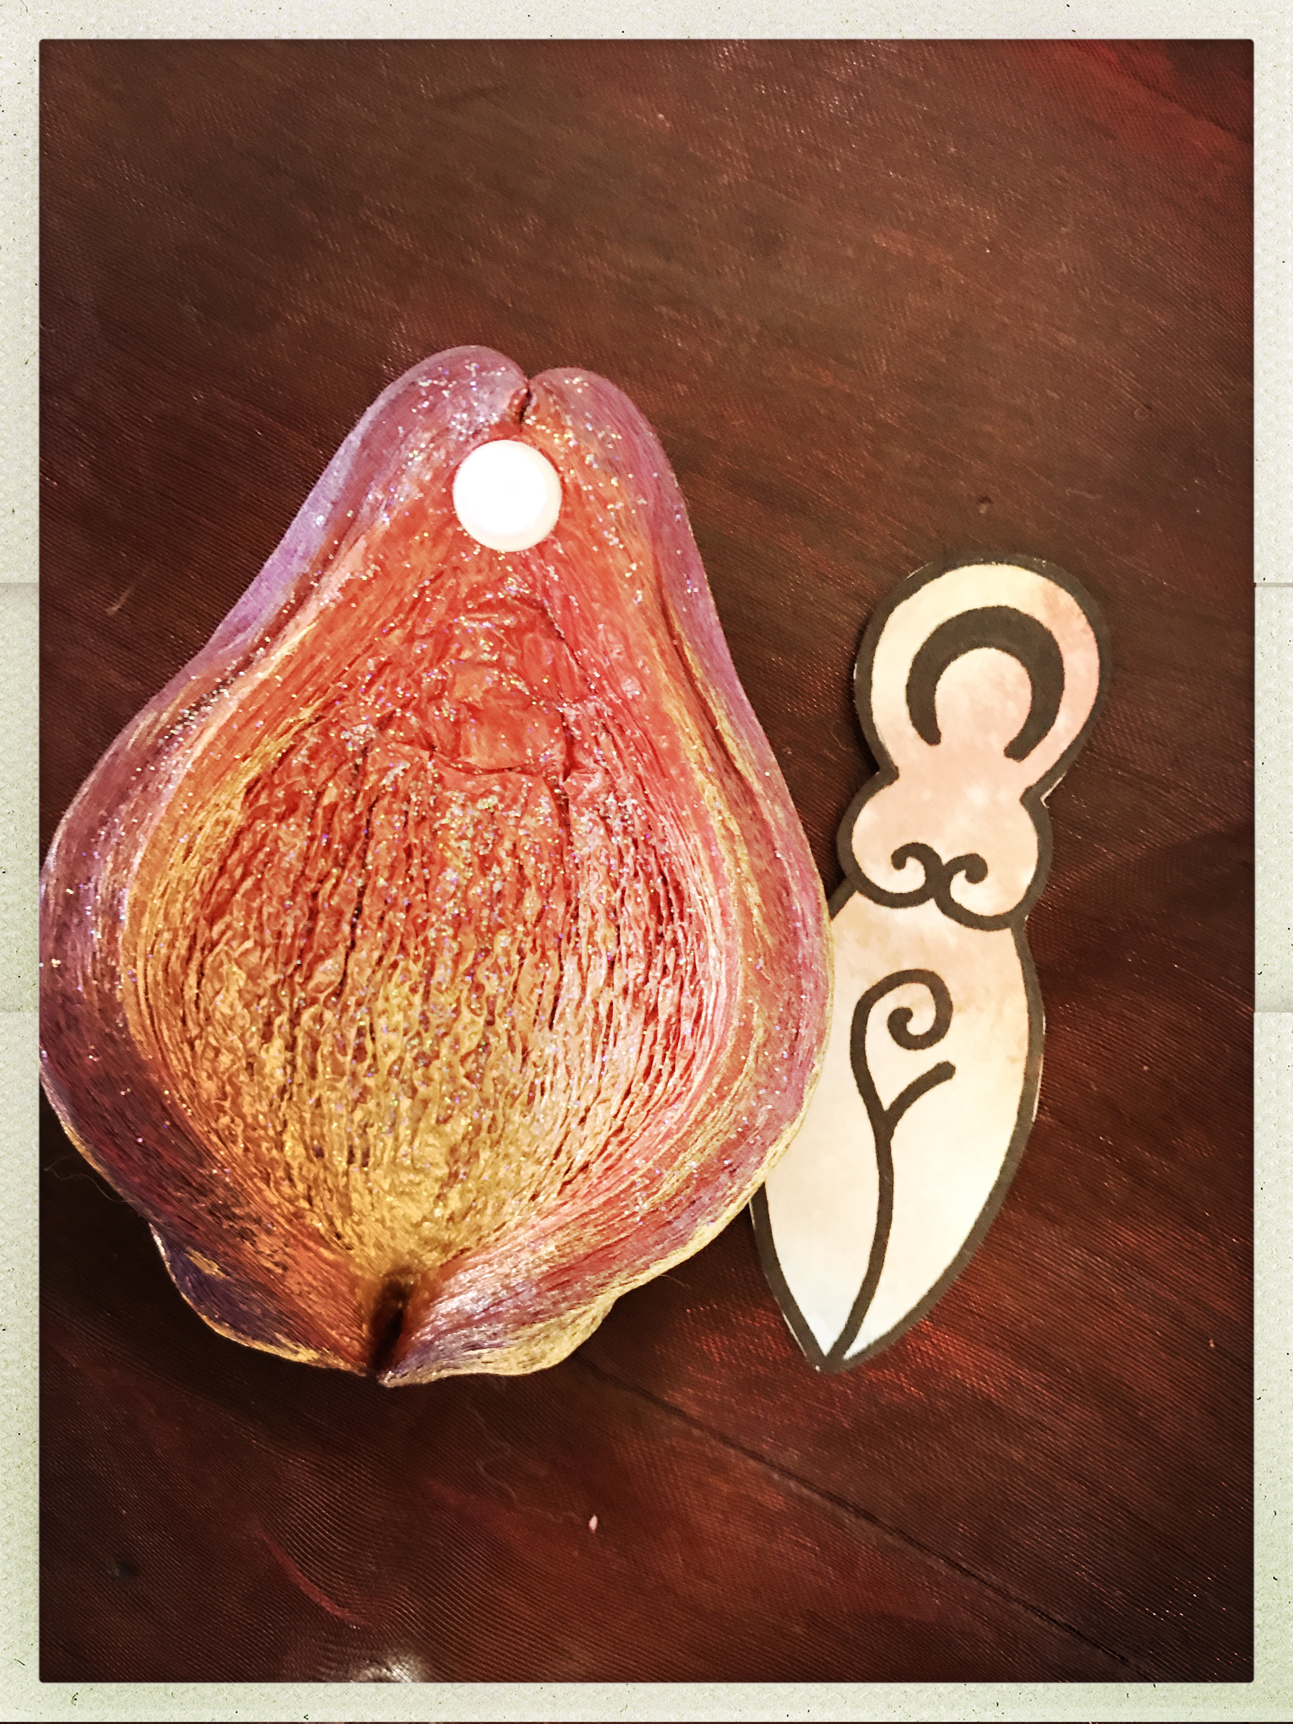
You will be required to complete between 12 - 18 case studies. These can comprise of a minimum of 1 client seen 4 times. The rest can be made up of individual sessions or regularly visiting clients. Ideally, you would like at least 1 fertility client that you see more than once however, as this therapy is for ALL women – this is not essential.

Creative Project
Fertility Massage is so much more than just a physical approach to massage. As therapists, helping other women to connect to their wombs and heal themselves, it is important the we too are connected to our wombs. This project is a creative expression of your womb.
Certification
Upon the 4 assessments being fulfilled, you will be issued with a Fertility Massage Certificate which is accredited by FHT, CThA, Think Tree and MMA (Australia)

Participant Requirements
Any woman who hears the call to work with women, their wombs and their empowerment!
You do not need to have any prior qualifications as Fertility Massage will soon be a fully accredited short course, comprising of Anatomy & Physiology, Health & Safety, Professional Conduct and the Massage techniques needed to fully perform Fertility Massage.
Fertility Massage Therapy is soon to be accredited by Think Tree Professional Body, with full insurance and membership available. Until this is in place, you are still able to attend with no prior qualifications and your certificate will be issued once all components are completed.
For Practitioners of complementary therapies who hold a recognised qualification in anatomy & physiology and are insured to touch the whole body, you will gain your certificate once all case studies/theory exam are completed as this course continues to be a CPD/CPE approved course with CTHA, FHT, IICT and MMA.

Course Size
There is a maximum of 16 participants per course. London courses will run with a minimum of 6 participants. The minimum number for International courses will vary.

Course Fee Inclusions
- 4 Day Intensive Course
- Practitioner Listing on website
- Access to Private Facebook Forum for invaluable ongoing support
- Certification & Exam Process
- Comprehensive Course E-Book, Theory Handouts and Videos
- Resources Page with visualisations, self help programme, e-books, articles and more
- Email/Telephone contact with Clare
- Practitioner DVD

** There are no membership fees

To Enrol:
To enrol and reserve your place on one of the courses, please email info@fertilitymassage.co.uk for an application form.
Reservation is secured with a non-refundable deposit of £100 (UK courses) via online banking. Full payment is required 6 weeks prior to the commencement of the course. Payment Plans are

Associate Instructors
From September courses will be hosted by myself and 8 other Womb Therapists who have all worked alongside me over the years and can offer the training with love and passion.
Each course will confirm the Tutor as per the website.
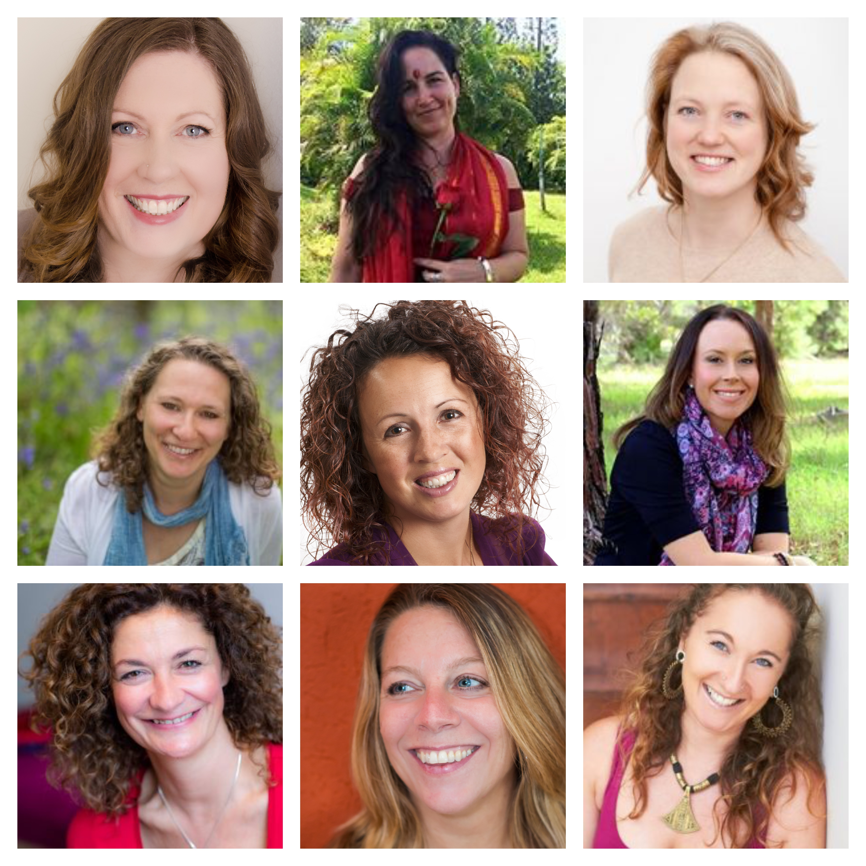
Carol Jones –Australia
Jacqui Ward –Australia
Rebecca Chisholm, Scotland
Leora Leboff - UK
Clare Spink - UK & Europe
Edwina Taylor - Australia
Andrea Clarke – UK
Janine De Wolf – Europe
Nat Love - Australia

Testimonials

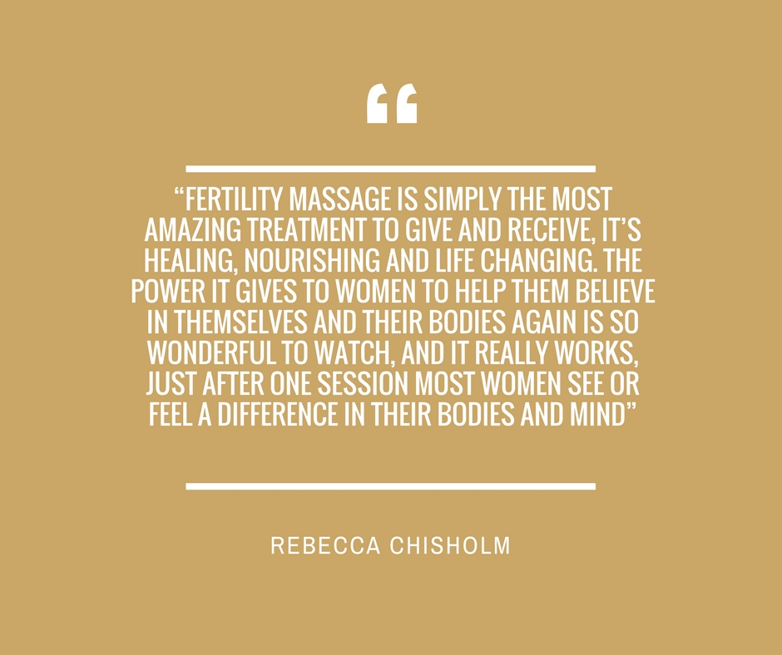

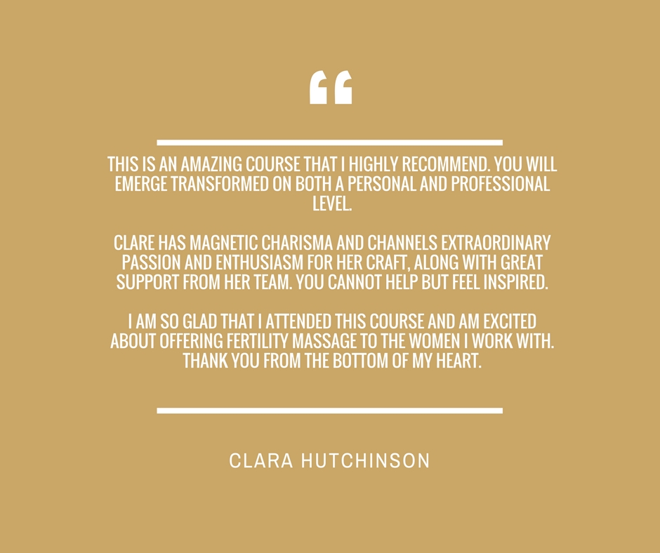
The womb blessing and visualisation underlines the power and spirituality of this work. Thank you for the kindness and nurturing of both yourself and group.
The practical parts are more than I ever imagined, lovely to give and receive and well guided in such a fun, peaceful and informative way.
Lindsey, 2016
This course is not just another “post graduate massage course” it will bring you very deeply into the spiritual and emotional aspects of working with both fertility clients and those with digestive ailments.

Clare encourages her “wombies” to develop their own style of working with the techniques she teaches which is a breath of fresh air! She is so passionate about her work and this shines through her teaching.

I would highly recommend this course to any therapist working not only with fertility clients, but all clients. This course is so much more than a fertility massage course.
Catriona, 2014

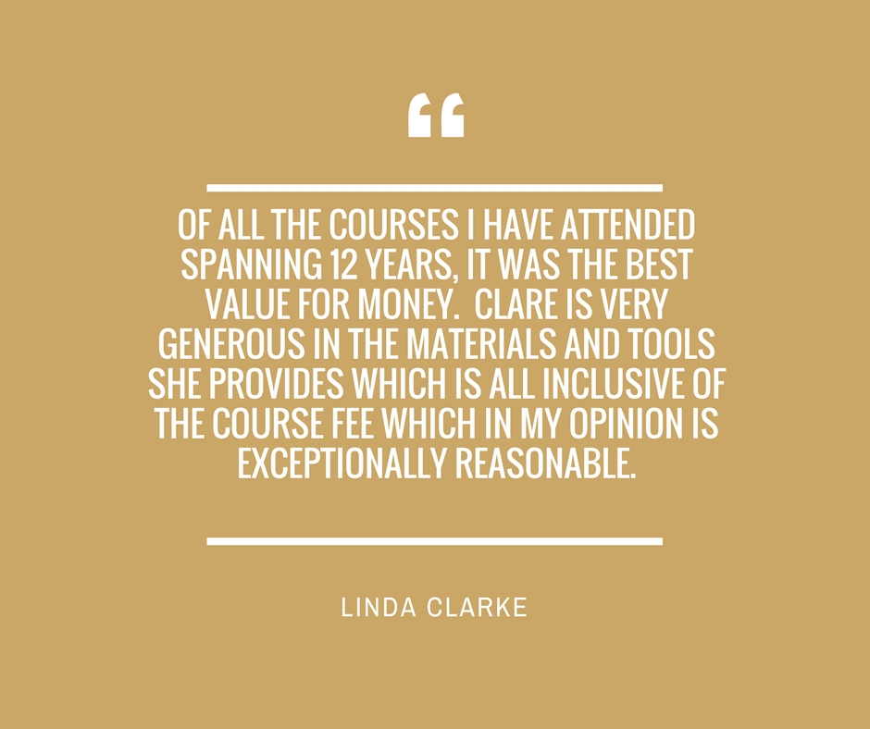
The Fertility Massage course has changed my life, literally, which I know does sound quite dramatic. It gave me focus and the confidence and tools to work with women who have fertility issues and other areas such as pregnancy loss and reproductive health issues.
It has opened up a world to me where I feel I can really make a difference and do a job that is so enjoyable and rewarding.
Clare is an amazing, experienced, Teacher who as well as having a great deal of knowledge, also works very much with an open heart. She is so grounded and approachable, but yet really tuned into the womb, healing energies and the mind, body and spirit connection.
Louise, 2018

Contact Us
If you have any questions, please feel free to contact
Clare Spink by email or phone.
e: info@fertilitymassage.co.uk
m: 07713 477511
I hope to meet you soon, to share my passion and knowledge with you and welcome you to this unique and divine therapy!
Warmest womb blessings
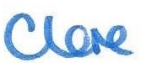

"Heal the Womb
Heal the Woman"

