Please complete this each session to help assess improvements

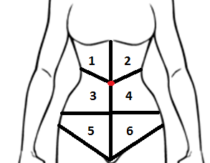
Temperature
Section 1 | Cool  Warm | Damp  Hot
Section2 | Cool  Warm | Damp  Hot
Section 3 | Cool  Warm | Damp  Hot
Section 4 | Cool  Warm | Damp  Hot
Section 5 | Cool  Warm | Damp  Hot
Section 6 | Cool  Warm | Damp  Hot

Palpation
Section 1 | Tender  Bloated | Hard  Scar
Section2 | Tender  Bloated | Hard  Scar
Section 3 | Tender  Bloated | Hard  Scar
Section 4 | Tender  Bloated | Hard  Scar
Section 5 | Tender  Bloated | Hard  Scar
Section 6 | Tender  Bloated | Hard  Scar

Client comments from previous session

Therapist Findings from this session

